**Lab 14: Mobile_App_Investigations_Messaging**

**Group: CyberSec_N00b**

#### Member:

#### Huỳnh Ngọc Quang (SE181838)

#### Hồ Tài Liên Vy Kha (SE181818)

#### Hoàng Kim Long (DE180860)

#### Phạm Thành Long (SE181692)

#### Nguyễn Lê Hoàng Thông (SE182533)

**Step 1**

* Download Pixel 3 image

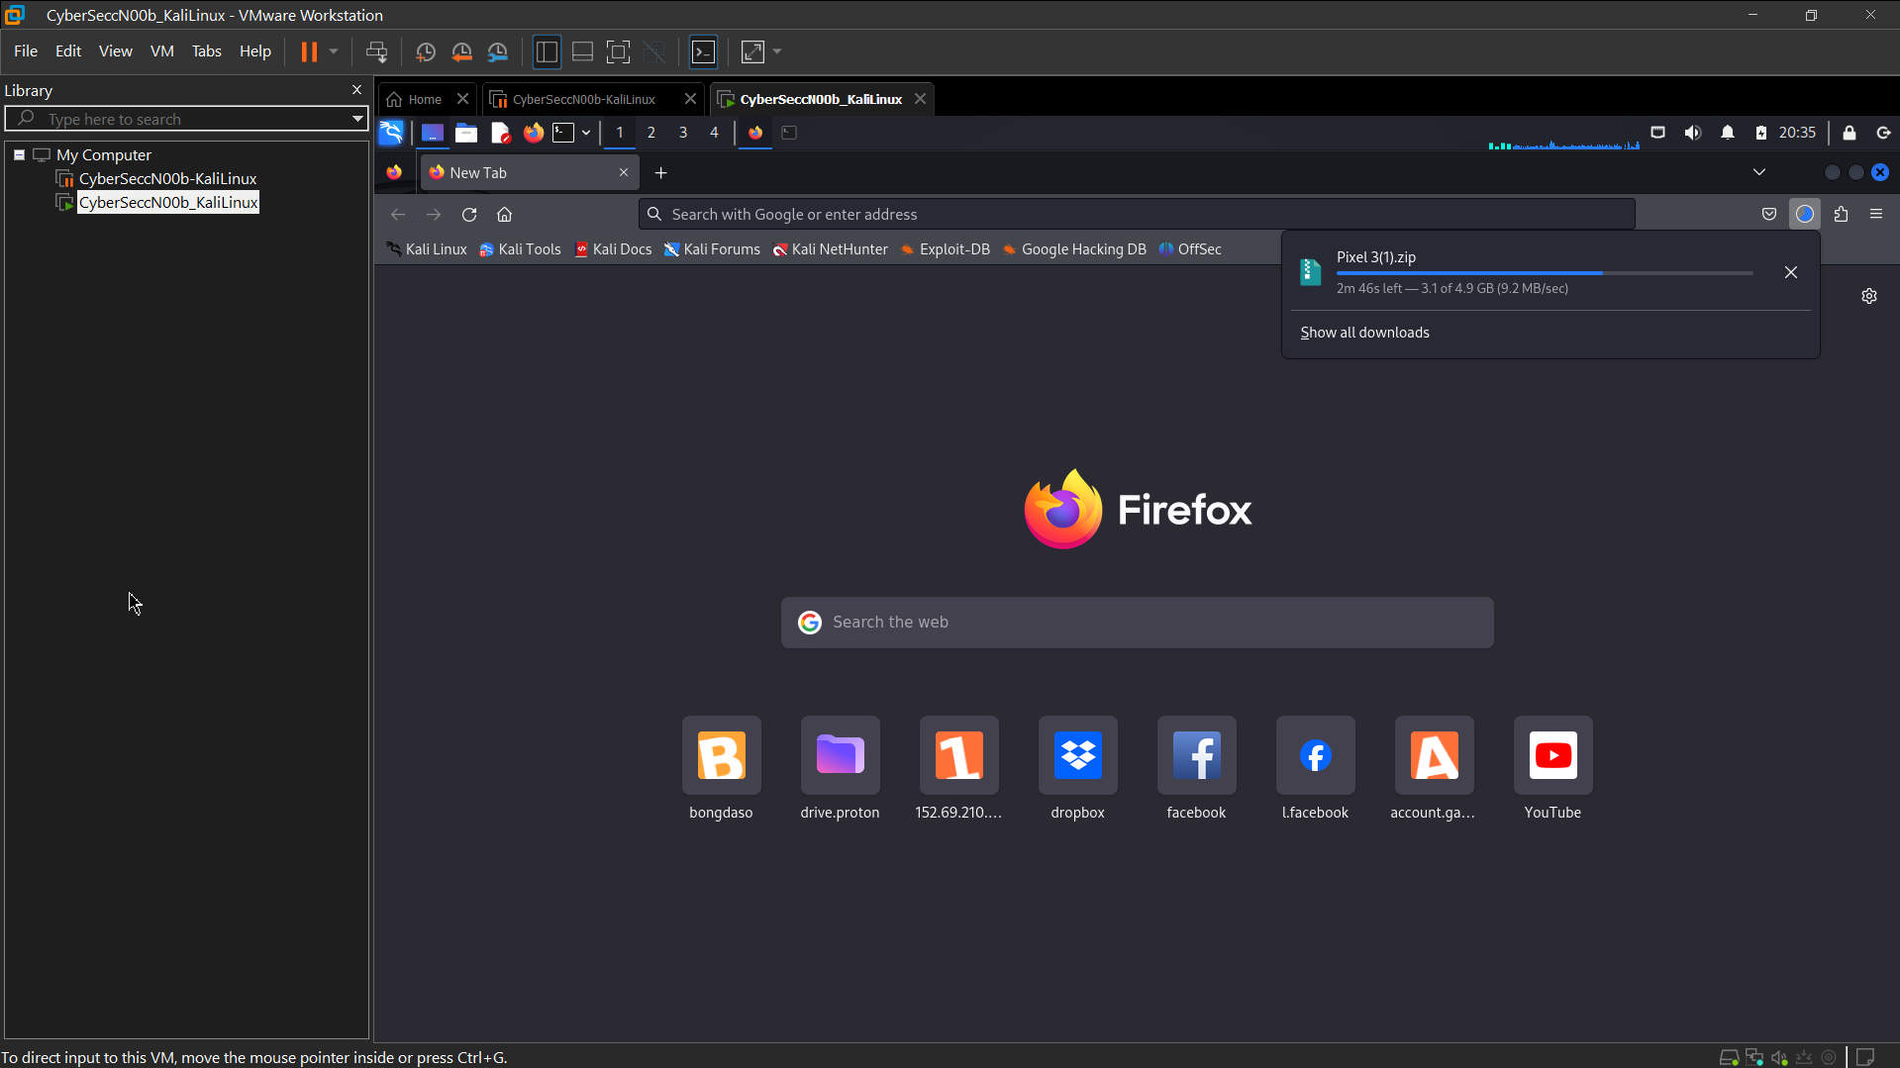 Verify hashes

hashdeep Pixel\ 3.zip

* A screenshot of a computer

  Description automatically generated unzip to get Pixel 3 image

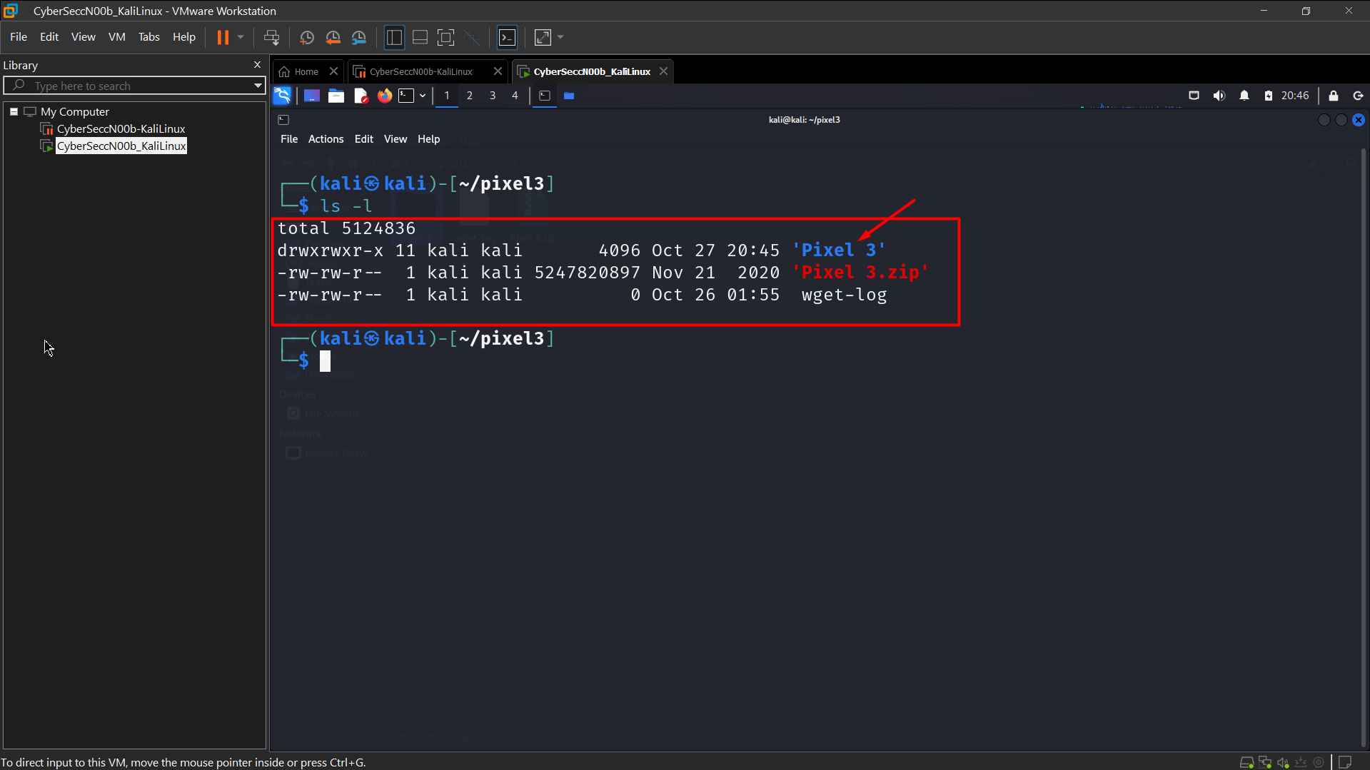 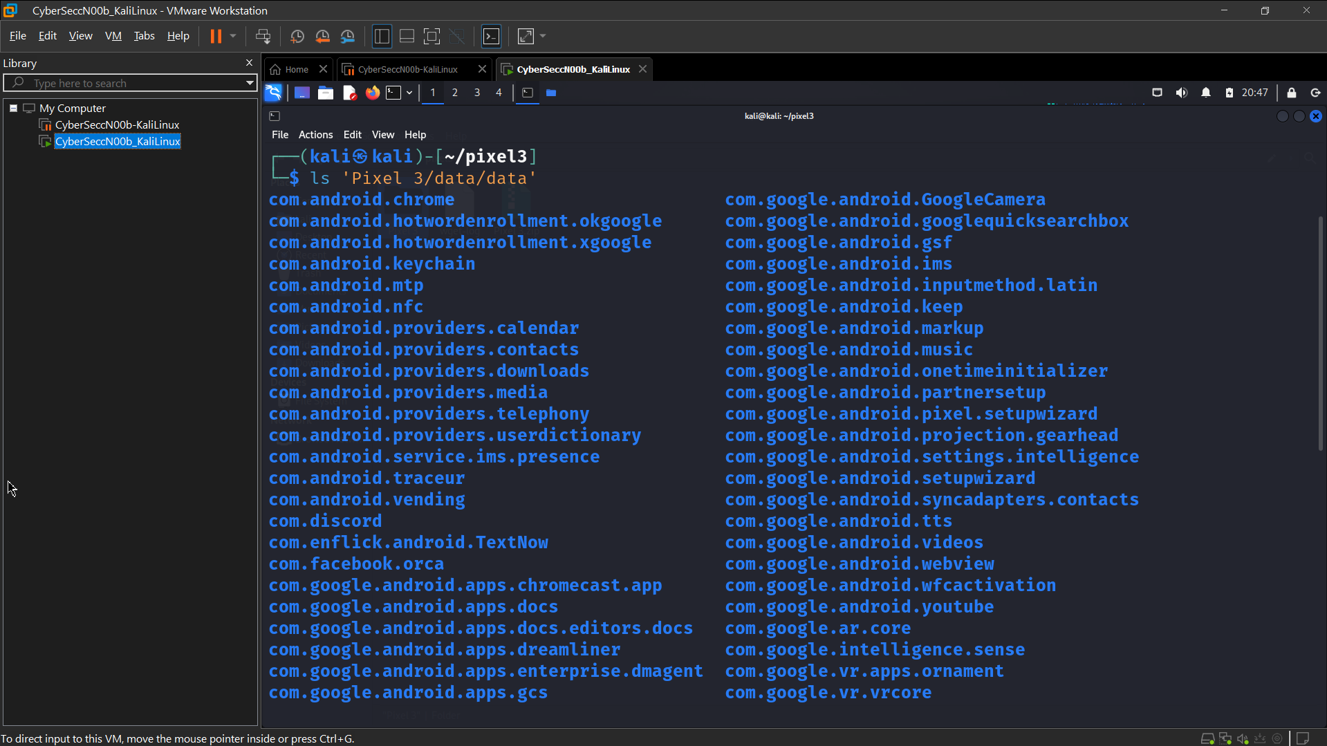 **Step 2. Investigating Messaging Services**

* Show all AOSP Apps/Packages: *com.andriod.\**
* 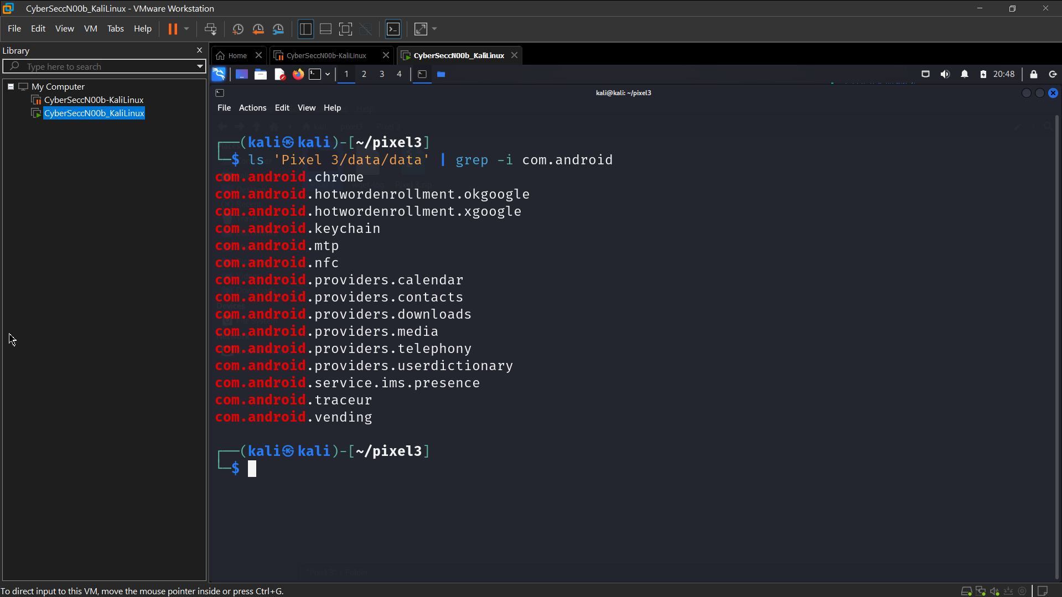 Find the location of Java package
* 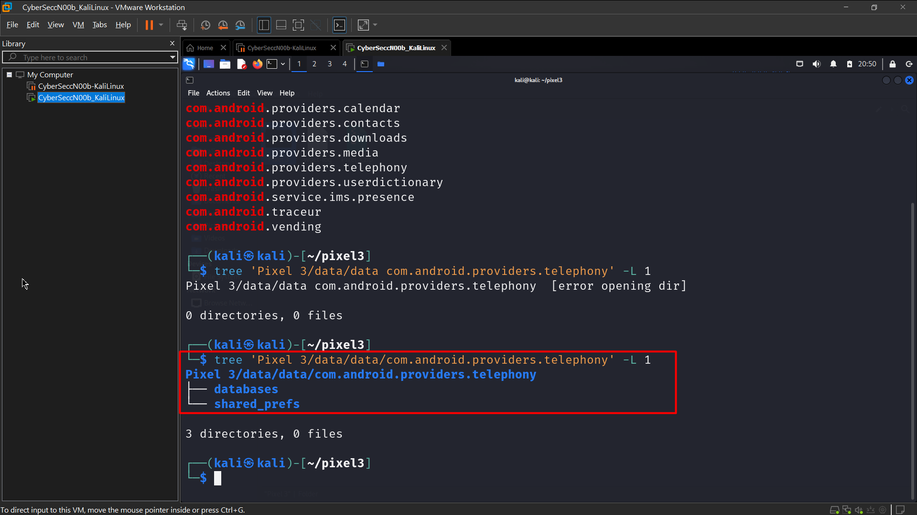 Find the database location
* 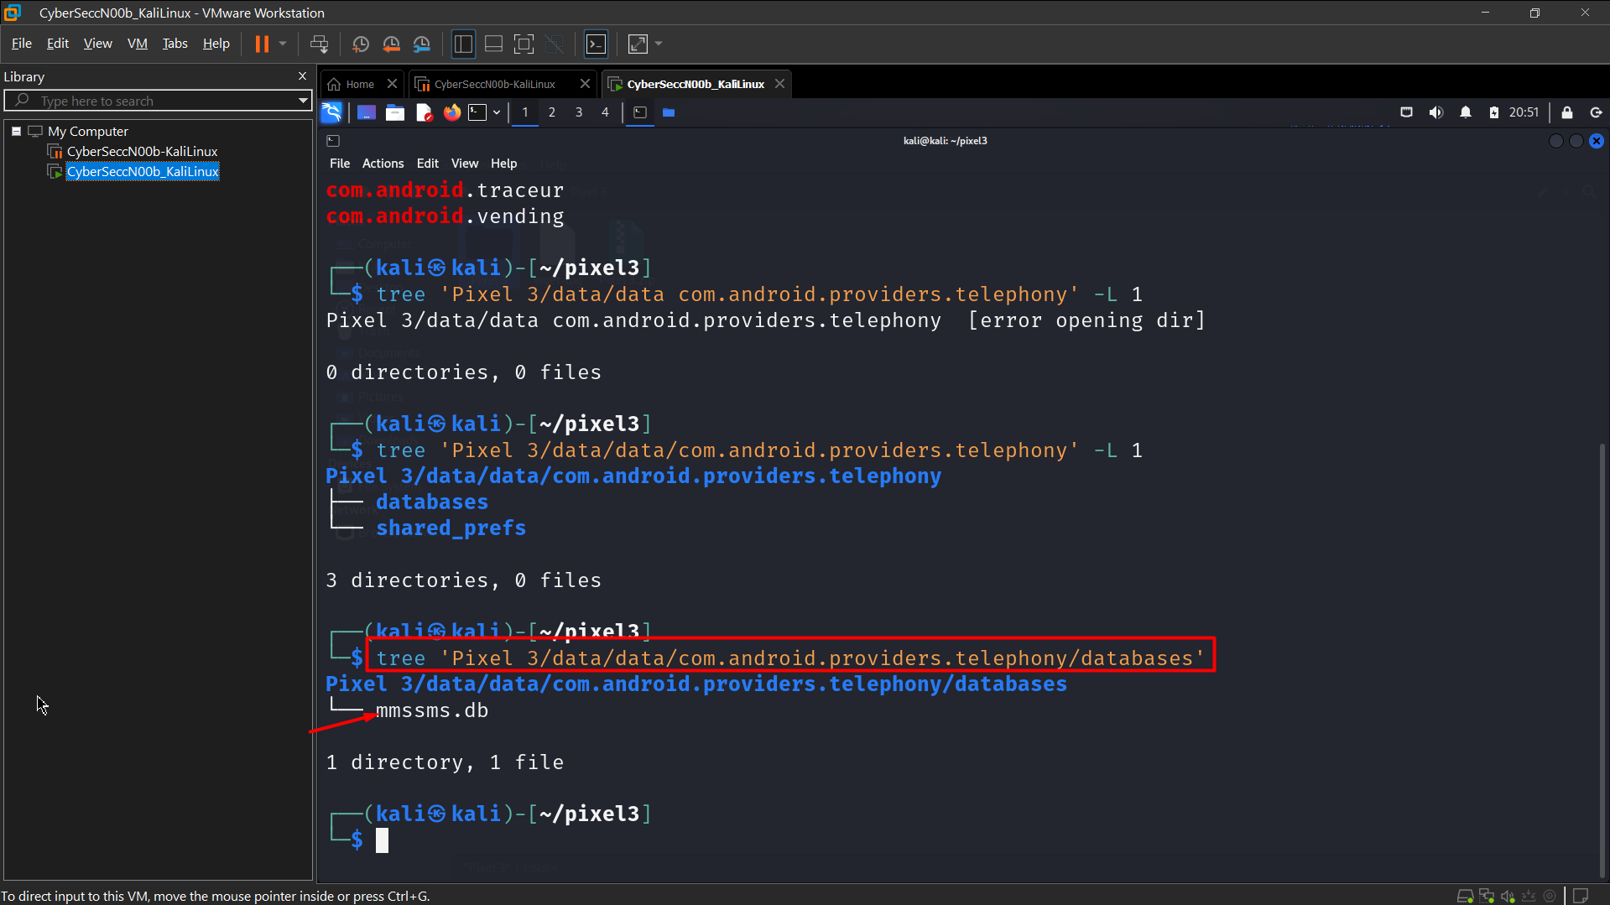 Show all tables in the database
* 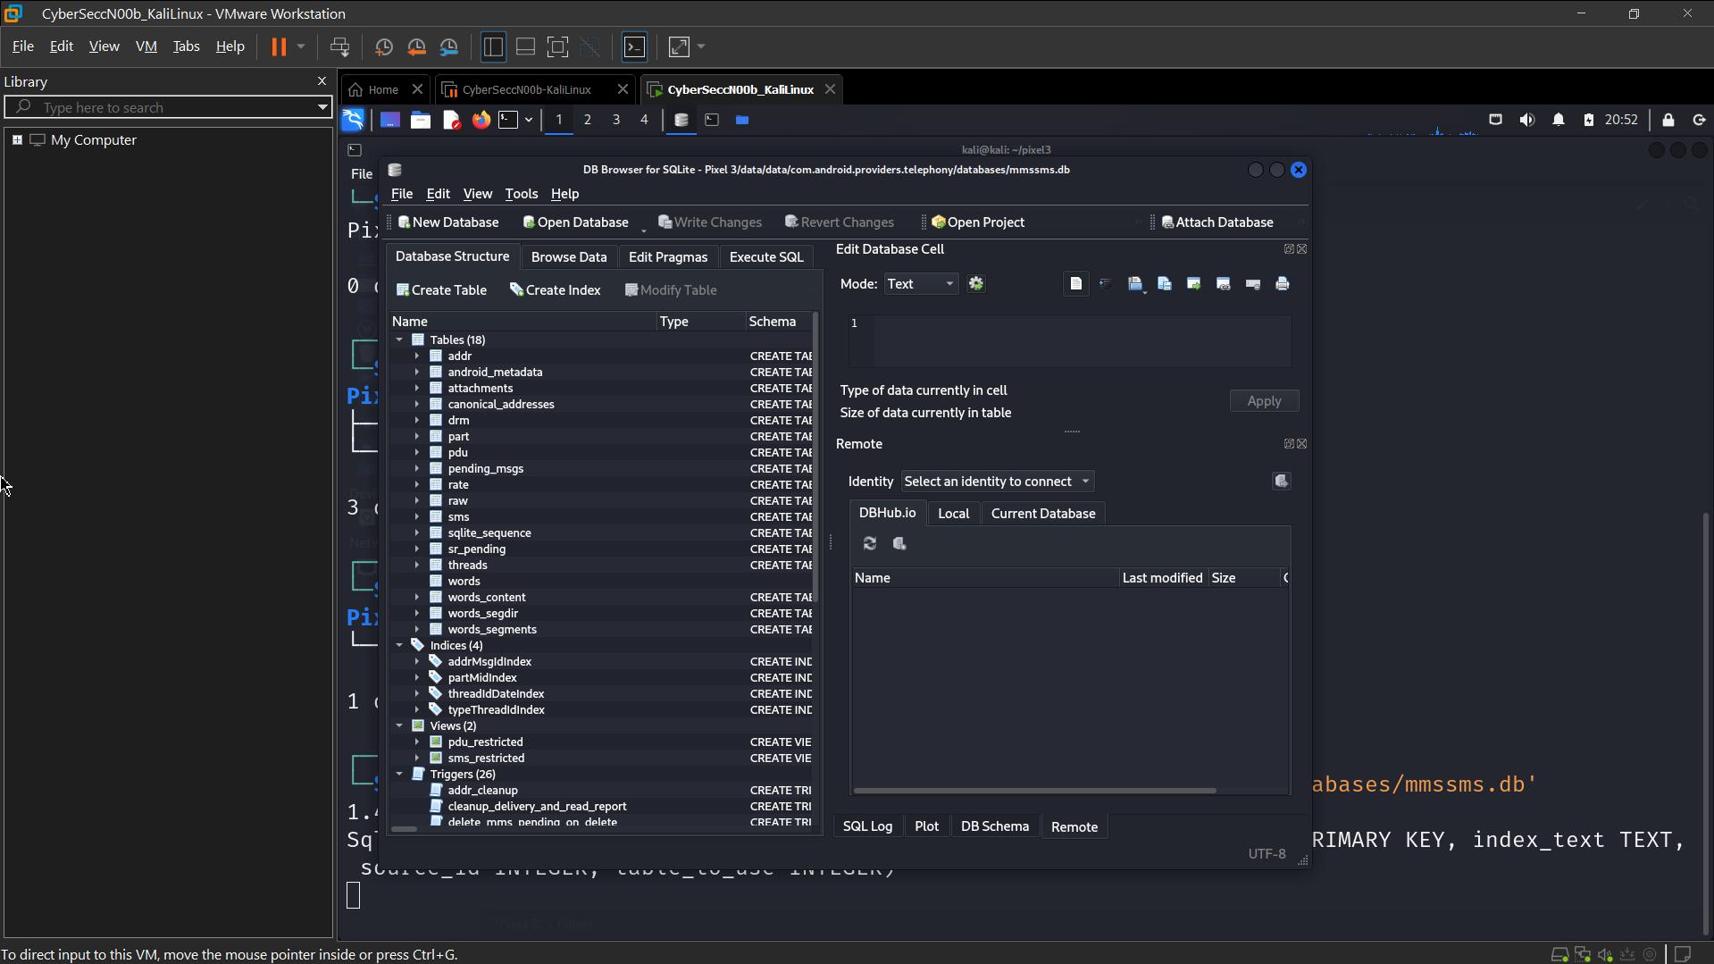 *sms*: message log
  + Only system, phone or the default message app can have full access of sms data
* *sms_restricted*:
  + Only contains sent or received messages.
* *threads*
  + Group all messages based on incoming phone numbers and time period?
  + Exam *sms* table structure
* 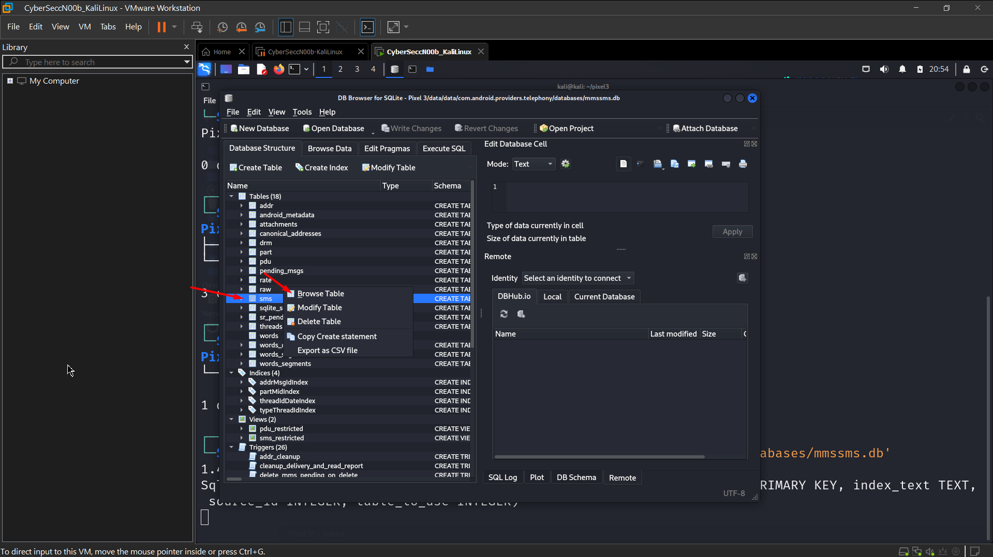 Find clues to answer the question
* 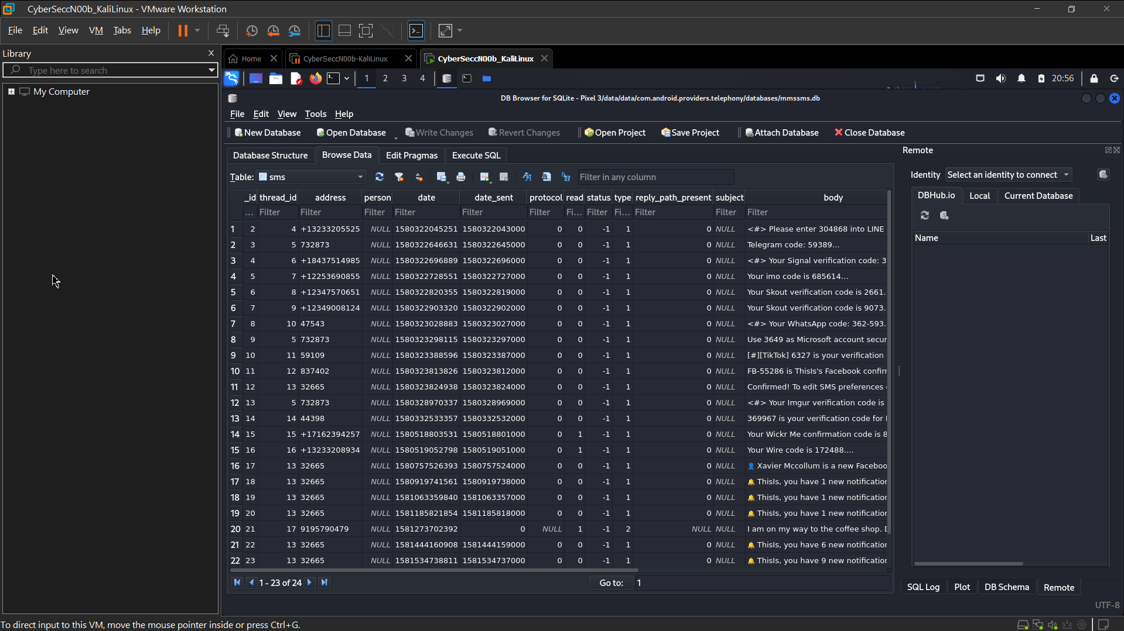 Which message was received on Jan 29, 2020 around 6:20 pm?

What table describes conversation?

Where to find sender’s phone number?

Exam *canonical_addresses* table

Which table contains MMS information ?

Part table stores below information:

* **_id:** Distinguish between different attachments of a multimedia message (including text, picture, audio, video and other formats)
* **ct:** indicates what type of attachment
* **data:** indicate where the attachment is stored on the phone
* **text:** Represents the body of the MMS.